Practical-7: Basic Programs Using Pointer

1) | Print value and address of a variable. (A)
Program :-
#include <stdio.h>
void main(){
int a = 0;
printf("Enter the Number : ");
scanf("%d",&a);
printf("%d is Store At address = %d",a,&a);
}
 | Output :-
 | 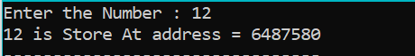
2) | Demonstrate int, float, double and char pointer.(A)
 | Program :-
#include <stdio.h>
void main(){
int a = 10;
float b = 12.34;
double c = 123.4567;
char d = 'd';
int *p1;//it can store only int data variable address
float *p2;
double *p3;
char *p4;
p1 = &a;
p2 = &b;
p3 = &c;
p4 = &d;
printf("int pointer -> %d \n",*p1);
printf("Float pointer -> %f \n",*p2);
printf("Double pointer -> %lf \n",*p3);
printf("char pointer -> %c",*p4);
}

 | Output :-
 | 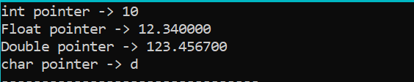
3) | Calculate sum of two numbers using pointer. (A)
 | Program :-
#include <stdio.h>
void main(){
int n1,n2;
printf("Enter the First Number : ");
scanf("%d",&n1);
printf("Enter the Second Number : ");
scanf("%d",&n2);
int *p1,*p2;
p1 = &n1;
p2 = &n2;
printf("%d + %d = %d",*p1,*p2,(*p1 + *p2));
}
 | Output :-
 | 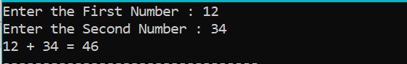
4) | Copy one array to another using pointers.(B)
 | Program :-
#include <stdio.h>
void main(){
int size = 0,i=0;
printf("Enter the size Of Array : ");
scanf("%d",&size);
int src[size];
for(i=0;i<size;i++){
printf("Enter the Number at idx %d :",i);
scanf("%d",&src[i]);
}
int copy[size];
int *srcPtr = src;
int *copyPtr = copy;
//*(arr+1) = arr[1]
for(i=0;i<size;i++){
*(copyPtr+i) = *(srcPtr+i);
}
printf("\nCopy Array : ");
for(i=0;i<size;i++){
printf("%d ",copy[i]);
}
}
 | Output :-
 | 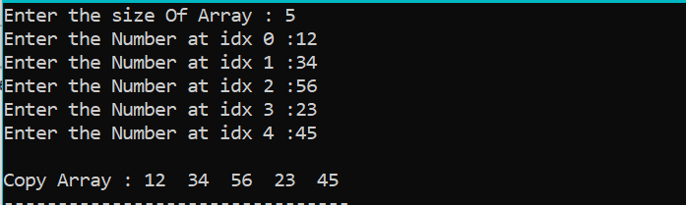
5) | Swap two arrays using pointers.(C)
 | Program :-
#include <stdio.h>
void main(){
int size = 0,i=0;
printf("Enter the size Of Array : ");
scanf("%d",&size);

//Array1
int arr1[size];
printf("\nEnter the value in Array1 : \n");
for(i=0;i<size;i++){
printf("Enter the Number at idx %d :",i);
scanf("%d",&arr1[i]);
}

//Array2
int arr2[size];
printf("\nEnter the value in Array2 : \n");
for(i=0;i<size;i++){
printf("Enter the Number at idx %d :",i);
scanf("%d",&arr2[i]);
}

//swap using pointer
int *ptr1 = arr1;
int *ptr2 = arr2;
int temp = 0;
for(i=0;i<size;i++){
temp = *(ptr2+i);
*(ptr2+i) = *(ptr1+i);
*(ptr1+i) = temp;
}

//Print Array1
printf("\nArray1 : \n");
for(i=0;i<size;i++){
printf("%d ",arr1[i]);
}

//Print Array2
printf("\nArray2 : \n");
for(i=0;i<size;i++){
printf("%d ",arr2[i]);
}
}

 | Output :-
 | 